Project Proposal

Predictive Maintenance Project

Author: Dhrubajyoti Ghosh

Contents

Brief on the Project 3
Dataset Features 4
Deliverables of the project 5
Approach Note 6
Model Selection 8
QnA 9
Model Information 11
Important Findings 11
Resources & Individual Details 12
Milestones 13

Brief on the Project
The purpose of this project is to develop a machine learning model that predicts whether a machine is likely to experience failure based on real-time sensor data. This will enable predictive maintenance strategies. This prediction will help in following manner:
- Reducing downtime: Through predictive maintenance, machines which are likely to encounter failures can be identified earlier and be replaced before they actually fail.
- Improving efficiency: Spares of the machines can also be procured earlier through early identification of probable faulty machines. This will reduce mean time to repair. Machines will remain operational for more time.
- Minimizing operational costs: Through predictive maintenance, if machines that are likely to fail are identified earlier, they can be maintained through proper planning before their actual failure. Hence, the operation will not come to complete standstill impacting costs.
The machine learning model will be developed through thorough analysis of the available dataset. The dataset consists of the parameters of sensor data under which the machine is likely to fail. The dataset will be used to train and test a classification model that will predict whether a machine is likely to fail or not based on the sensor data.

Dataset Features
The dataset has 9 features. Each record/row represents a machine’s operational status under specific condition. The purpose is to use these variables to predict the likelihood of a machine failure. The critical parameters of the dataset are as follows:
- Type: Categorical variable that highlights the machine type. Low (L), Medium (M), High (H).
- Air temperature [K]: Continuous floating variable that records the temperature of the surrounding air in Kelvin.
- Process temperature [K]: Continuous floating variable that records the temperature during the manufacturing process in Kelvin.
- Rotational speed [rpm]: Continuous integer variable that records speed of machine’s rotation in revolutions per minute (RPM).
- Torque [Nm]: Continuous floating variable that records Torque produced by the machine in Newton-meters.
- Tool wear [min]: Continuous integer variable that records amount of wear on the tool in minutes of usage.
- Target: This is the final output that indicates machine failure. It is a binary field. Here, 0 indicates no failure and 1 indicates Failure.
Apart from these fields, UDI, an integer field, is present that is an unique identifier for each machine record. And, Product ID, of type String, that identifies the machine’s product category. Since, both these fields are unique identifiers only hence they are not used in development of the predictive machine learning model.

Deliverables of the project
- Jupyter Notebook: It contains the python code that does the following:
  - Imports and analyses the dataset.
  - Transforms the data to remove anomalies or inconsistencies.
  - Splits the data into training and testing dataset.
  - Scales the data to fit into machine learning model.
  - Compares performance of various machine learning algorithms against the training and testing data and identifies the best model.
- Pickle Files: The identified best machine learning model and subsequent transformations are exported through the pickle files. The project has the following pickle files:
  - Label Encoder Pickle File: It label encodes the type column of the dataset.
  - Power Transformer Pickle File: Used to remove skewness of the dataset.
  - Scaler Transformer Pickle File: Feature scaling technique used to standardise the dataset.
  - Machine Learning Model Pickle File: Contains the finalised selected Machine Learning Model.
- Front end Code: It does the following:
  - Imports the Pickles Files mentioned above.
  - Uses Streamlit to design the front end that takes the sensor parameters as input.
  - Transforms the input sensor parameters using the various transformations imported through the pickle files.
  - Used the imported machine learning model and predicts if a machine is likely to experience failure.
  - Displays the predicted result.
- Project Report File: A word document provides comprehensive overview of the project, outlining the approach used towards development of the machine learning model. The various challenges encountered during the process and the key factors that influenced selection of the final machine learning model.

Approach Note
- After importing the basic libraries, the dataset is loaded into a dataframe.
- Column names of the dataframe are standardised to prevent subsequent issues.
- Summary about the dataframe is generated to see the structure and summary of the dataframe.
- The dataframe was checked for duplicate values. Since no duplicate records were found, no duplicate removal was required.
- Value count of target variables was checked for class imbalance. Class imbalance was identified. There were only approx. 300+ cases where machine was identified to fail.
- The value counts of the target variable were analysed to assess class imbalance. A significant class imbalance was identified, with only approximately 300+ instances in which the machine was classified as failing.
- Then it was checked if UID and Product IDs were unique identifiers. It was found to be true. Hecne, they were removed from input features.
- The correlation amongst the feature variables were inspected. From the correlation heatmap, it was identified that there was strong positive correlation between air temperature and process temperature and strong negative correlation between rotational speed and torque.
- Variance Inflation Factor (VIF) was used to detect multicollinearity amongst the input features. It was found only air temperature and process temperature to be highly collinear. However, both the temperatures are critical in determining the chances of machine failure. Hence, it was decided to retain both the features.
- The dataset was first divided into feature (X) and target (Y) variables, followed by a train–test split. Since the dataset is class-imbalanced, stratified sampling was applied based on the target variable to preserve the original class distribution in both the training and testing sets.
- For handling class imbalance, first SMOTE Tomek and then Random Under-Sampling were used.
- Comparisons were performed among the various Machine Learning Models to achieve the best training and testing accuracy using the following datasets.
  - Original dataset
  - Class-imbalanced dataset balanced using SMOTE-Tomek
  - Class-imbalanced dataset balanced using Random Under-Sampling
- Following Machine Learning Models were used for evaluation:
  - Logistic Regression
  - Decision Tree
  - Random Forest
  - K-Nearest Neighbors (KNN)
  - Support Vector Machine (SVM)
  - Naive Bayes
  - AdaBoost
  - Bagging
  - Gradient Boosting
  - XGBoost
- XGBoost on original dataset showed the highest accuracy and least difference between training and testing dataset.
- Machine Learning Models using the dataset balanced using Random Under-Sampling showed least accuracy with high difference between training and testing accuracy.
- The accuracies of machine learning models using original dataset and using the dataset balanced using SMOTE-Tomek seemed comparable. So, we tried to hyperparameter tune the models using the dataset balanced using SMOTE-Tomek.
- Though hyperparameter tuned XGBoost model seemed to have marginal lower accuracy yet the gap between the training and testing accuracies lowered further.
- In parallel, the XGBoost model was also hyperparameter-tuned using the original dataset. The resulting training and testing accuracies were found to be very similar to those of the other model.
- The results were very close for both these models. Hence, we proceeded towards Confusion matrix, Precision-Recall and AUC-ROC curve for further analysis.
- After finalising the model, the model and transformations like Label Encoder, Power Transformer and Scaler transforms are converted to pickle file and exported.
- The generated pickle files were imported into Visual Studio Code, where the project's front end was developed using Streamlit.
- In the front end, users provide values for the finalized input features. These inputs are then transformed using the corresponding imported pickle files.
- The transformed input data is passed to the trained machine learning model to generate the prediction.

Model Selection
ML Model | Actual: 0  Predicted: 0 | Actual: 0  Predicted: 1 | Actual: 1  Predicted: 0 | Actual: 1  Predicted: 1
Hyperparameter Tuned XGBoost on SMOTE Tomek Dataset | 2414 | 1 | 74 | 11
XGBoost Model on SMOTE Tomek Dataset | 2343 | 72 | 16 | 69
Hyperparameter Tuned XGBoost on Original Dataset | 2403 | 12 | 46 | 39

Legends
0 | No Failure
1 | Failure

  - Hyperparameter tuned XGBoost Model using the dataset Class-imbalanced dataset balanced using SMOTE-Tomek seems to have least average precision score. Hence, we are rejecting this model.
  - On paper, Hyperparameter tuned XGBoost Model using the original dataset seems more balanced. It has average precision value of 0.71 and AUC value 0.98 which is comparable to the XGBoost Model using the dataset where Class-imbalanced dataset balanced using SMOTE-Tomek. However, there were 46 cases where actual value was failure but predicted value was No Failure.
  - On the other hand, XGBoost Model using the dataset where Class-imbalanced dataset balanced using SMOTE-Tomek seems to be most aggressive model. It has highest average precision value of 0.76 and AUC value 0.97. However, if we observe the confusion matrix, we identify higher cases of false alarms. There are 72 cases where actual value is 0 but predicted value is 1. But, considering preventive maintenance, this is acceptable to me as this will lead to lesser cases where predicted value is not failed but actually it has failed. Hence, finalised this model.

QnA
Q1. Which types of machines are more likely to experience failure?
Ans: Type Low(L)
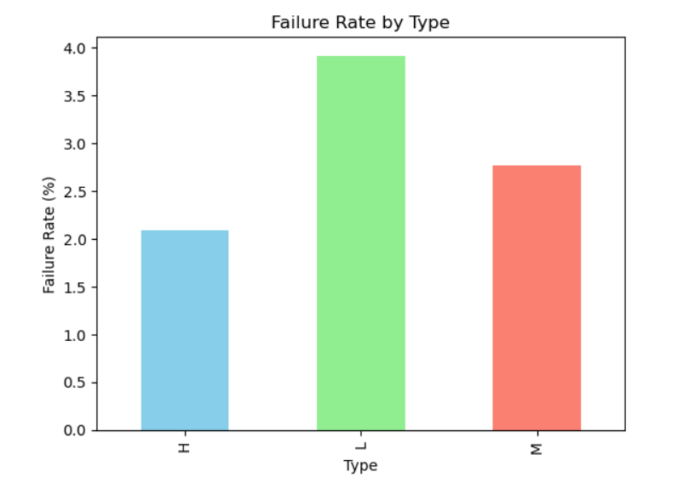
Q2. How Process and Air temperature impacts chances of failure or machines?
Ans: Though there are multiple factors that impact the chances of failure of machines apart from these 2 parameters. However, it has been observed, machines are likely to experience more failure if air temperature increases beyond 302 K and process temperature increases beyond 310 K.
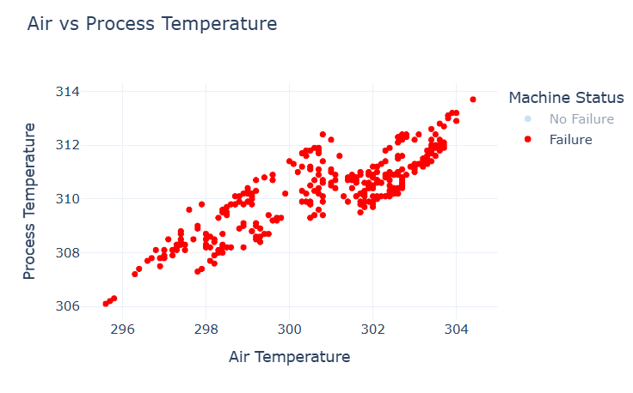
Q3. How Torque impacts the chances of failure of machines?
Ans: Machine failure depends on multiple parameters. However, it has been observed, machines with higher torque above 50 Nm are more likely to experience failure.
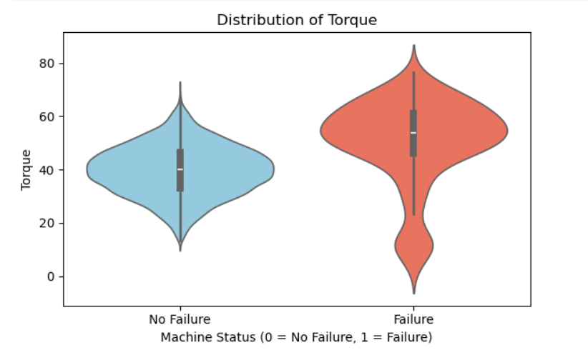

Model Information
Machine Learning Model Used: Hyperparameter Tuned XGBoost Model
Method used to handle Class Imbalance: SMOTE Tomek
Method used to encode categorical data: Label Encoder
Transformer used to handle Skewness: Power Transformer
Feature Scaling technique used: MinMax Scaler
Python Version: 3.12
scikit-learn Version: 1.8.0

Important Findings
The XGBoost model using the original dataset exhibited a higher number of false negatives, meaning the model predicted No Failure when the machine had actually Failed. Similar observations can be stated for the finalised model where the cases of False positives were more. However, this scenario will result in better predictive maintenance and less downtime. Hence, this model has been adopted. Also, if we see the overall percentage, this figure is very low.
Also, through Variance inflation factor (VIF), it was observed air temperature and process temperature were highly collinear. However, both the factors are necessary to identify the scenario where machine can fail. Hence, both features have been retained.
Sample Output

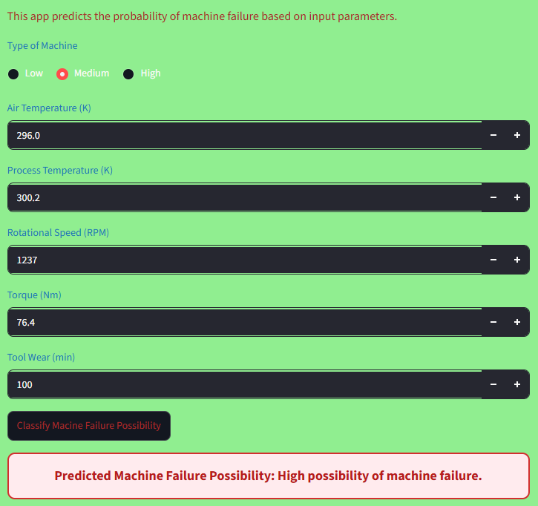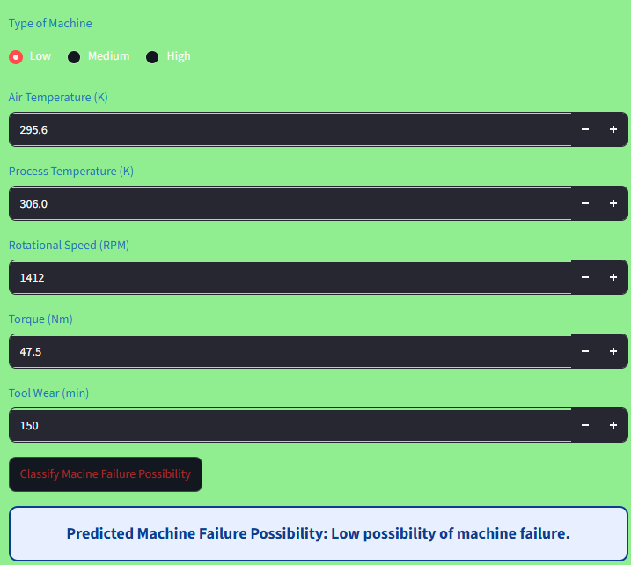

Resources & Individual Details
Data set source: The dataset has been downloaded from the portal. The data can be fetched through senor parameters through frequent interval of time. It can be further used to train the model and improve its accuracy further.
Software: Jupyter Notebook, Visual Studio Code, Streamlit & GutHub
References:
- https://www.geeksforgeeks.org/
- https://chatgpt.com/
- https://gemini.google.com/?hl=en-IN

Individual Details:
Name: Dhurbajyoti Ghosh
Email: <DND>
Phone Number: <DND>
*DND – information not shared for data privacy

Milestones
Define a problem | Develop a machine learning model to predict whether a machine is likely to experience failure.
Understanding the business problem | Business expects the machine learning model to predict whether a machine may experience failure based on sensor output for predictive maintenance.
Get the Data | Data shared in portal is loaded into Pandas Dataframe
Explore and pre-process data | The dataset contains nine features: eight input features and one output feature. Among the input features, UDI and Product ID are unique identifiers and are therefore excluded from the model inputs. Target is the output feature. Remaining Type, Air Temperature, Process Temperature, Rotational Speed, Torque and Tool Wear are considered as input features.
Choosing the python platform | Python Version: 3.12  scikit-learn Version: 1.8.0
Create Features | Initially, due to high collinearity between Air Temperature and Process Temperature, it was planned to drop Air Temperature. However, both are critical parameters in determining machine functionality. Hence, both has been retained. Similarly, rotational speed and torque are highly negatively correlated. But, due to relatively less multicollinearity by calculating VIF, both has been retained.
EDA | Dataset doesn’t contain any Blank (null) or duplicate value. However, class imbalance has been identified that has been handled through SMOTE Tomek.
Create Model | Following models are evaluated through cross validation and accuracy on original dataset and dataset balanced through SMOTE Tomek and Random Under-Sampling:  - Logistic Regression  - Decision Tree  - Random Forest  - K-Nearest Neighbors (KNN)  - Support Vector Machine (SVM)  - Naive Bayes  - AdaBoost  - Bagging  - Gradient Boosting  - XGBoost
Model Evaluation | XGBoost model using dataset balanced using SMOTE Tomek has been finalised due to high accuracy, less training and testing accuracy difference, better AUC ROC curve and better confusion matrix.
Report Writing | Report is uploaded on below link in GitHub:  https://github.com/Dhruba041/ML_CAP_08_PREVENTIVE_MAINTENANCE
Project submission | Project GitHub Link:  https://github.com/Dhruba041/ML_CAP_08_PREVENTIVE_MAINTENANCE  Project Front End Link:  https://mlcap08preventivemaintenance-whacfj3ngvfpcxjoot6kvv.streamlit.app/

